Arfain Ulla Shariff

PROFESSIONAL SUMMARY
Dedicated Branch Officer with extensive expertise in customer service and sales. Proven track record of ensuring adherence to regulatory standards while delivering exceptional customer experiences. Adept at maintaining meticulous records, resolving customer complaints, and promoting products and services within compliance frameworks. Possess a strong understanding of CRM systems and practices. Known for maintaining composure in high- pressure situations, resulting in successful outcomes.

WORK HISTORY
Teller (Customer Service Agent)
Redha al Ansari Exchange, Dubai, UAE - Dubai, Uae
Responsibilities:

03/2022 - 03/2024



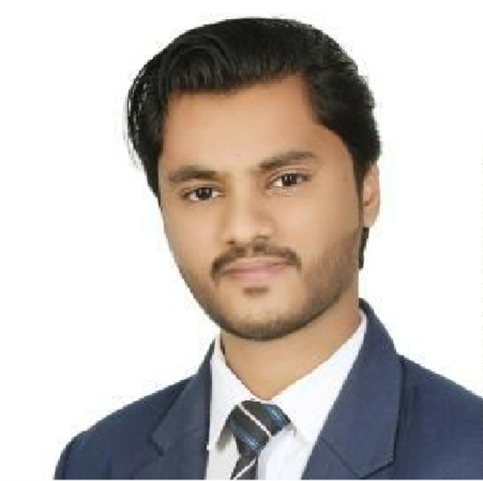
- Processing international and local money transfers, including bank-to- bank transactions, cash pickups, and correspondent bank dealings.
CONTACT
Dubai, UAE
+971527747095
arfainullashariff@gmail.com 22/05/1999
Indian
SKILLS
Career skills:
- Workflow planning
- Communication skills
- Risk Assessment
- Policy Implementation
- Due Diligence
- Legal Compliance
- Time Management
- Adaptability
- Active Listening
- Conflict Resolution
Computer skills:
- MS Office (Word & Excel)
- MS Windows
LANGUAGES
English
Upper intermediate
Hindi
Intermediate
B2
B1
- Accepting various types of bills, such as electricity, Du, Etisalat, and fine payments.
- Possessing sufficient knowledge of different currencies and their rates.
- Opening WPS account for companies in accordance with Ministry of Labor requirements.
- Collecting WPS salaries of the companies.
- WPS cash salary payout to employees.
- Issuing or requesting ATM cards for WPS employees.
- Accepting payments for Air Arabia and Fly Dubai.
- Providing main reports to the management and the account department.
- Deriving revenue through delivering service excellence, cross-selling, and identifying growth opportunities.
- Ensuring all services comply with CBUAE policies and procedures.
- Identifying and reporting any suspicious customer activities to relevant departments.
- Updating rates accurately based on forex rates.

EDUCATION
Bachelor Of Commerce (B.com), 2021
Hoysaleshwara college – Arsikere, India

HOBBIES
Drawing, Dancing, YouTube content creator,

