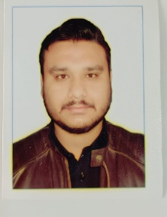
Zeshan Qamar
Born In Qatar, Doha
Contact No# +97431535461
Email Address: zeeshankhan5251@gmail.com

OBJECTIVES:
To secure a challenging position in a reputable organization to expand my learnings, knowledge, and skills.
EDUCATIONS:
Bachelor’s in Computer Science (BS-SE) | Sarhad University Of Science And Technology
Intermediate | Board Of Intermediate Peshawar ,Pakistan
Matriculation | Board Of secondary Education Peshawar,Pak
Diploma Of Information Technology (D.I.T) | Technical Board Of Peshawar,Pakistan
Safety Certificates | Institution of occupation safety and health(IOSH )+Occupation Safety and Health Administration(OSHA).

SKILL’S:
MS Office:
- MS Word
- MS Excel Sheet
- MS Power Point
- Python ,HTML,CSS,C++(Basic).

EXPERIENCE:
- 1 Year Experience In Qarshi Jame-E-Shirin (Computer Operator+Junior Audit Officer).
- 1 Year Experience In High Q Medical Company(K.P.O) And Sales Person .
- 2 Year Experience In Dalda Cooking oil as a supervisor.
- 1 Year Teaching Experience as tuition Teacher math and physics .
- 6 Month Experience in UCC as part time foreman.(2022/07 to 2022/12).
- 8 Month Experience as safety officer + security guard in GET side Lusail (2023/03 to 2023/10).

PERSONAL INFORMATION:
Father Name | Fazal Khadi
Date Of Birth | 1993-04-09 Doha
Gender/Nationality | Male/Pakistan
Passport Number | AK3724922
Qatar I,D Number | 29358607772
Religion | Muslim

Hobbies:

- Plying Video games
- Plying cricket .
- Programming in Computer Language like (Python,Html,CSS).
- Like to Work On Computer.

WHAT’S APP# +97431535461

