Good Day.
(HR Dept/Employer),

I, Charyl Elija L. Diola, with a degree of Bachelor of Arts Major in Communication, would like to inquire and apply for a position sufficient to my qualification.
If you are looking for an employee who would do well in Data Entry handling, Bank Account Coordinating, Record keeping, Customer service and Human resource, I would like to inquire if I may be able to be a part of your community with the privilege of your company’s assistance. I know that working for a growing company will bring challenges. I am confident that my past experiences as a Communication Student in Adamson University, a former Customer Service Associate (both teller and new accounts) in Philippine Savings Bank and Data Entry associate in ING Bank, will further be good with my work ethics that would allow me to be an asset to your team. I would love the opportunity to talk in more detail about positions that exist and/or available.
If there are no job openings, I would be grateful if you will keep my resume for future possibilities.

Thank you.
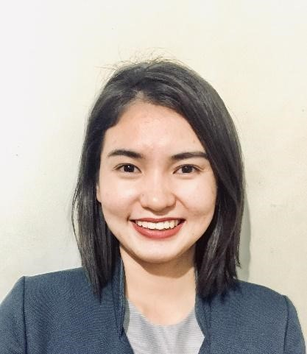

CHARYL ELIJA L. DIOLA
Doha, Qatar

charyl.diola@gmail.com
Whatsapp: +974 72161734

JOB OBJECTIVE

To be associated and be a part of the esteemed organization who will provide me with a dynamic work sphere to extract my inherent skills as a Professional. It would be challenging for me to build my career in the leading corporate environment with committed and dedicated people, which will help me to explore myself and work as a key player.
I am a proactive, hardworking, result-oriented individual and resourceful team player with a sound and optimistic outlook in life. I possess an excellent ability to motivate others; coupled with the ability to communicate comfortably at all levels and I trust I will be an excellent support in accomplishing the objective of the team/organization.

EDUCATION & TRAINING

TERTIARY:  SECONDARY:  PRIMARY: |  | College Degree of BACHELOR OF ARTS MAJOR IN COMMUNICATION  Year Graduated: 2011-2015  Adamson University - Manila, Philippines  CAMELLA SCHOOL INSTITUTE – Manila, Philippines  Year Graduated: 2007-2011  CAMELLA SCHOOL INSTITUTE – Manila, Philippines
Year Graduated: 2000-2007

WORK EXPERIENCE

COMPANY: PHILIPPINE SAVINGS BANK
JOB POSITION: Customer Service Associate TENURE : October 2015 – March 2023

Duties & Responsibilities

- Responsible for interviewing and record keeping of customers.
- Responsible for maintaining the confidentiality of new accounts or client personal information.
- Responsible for reporting any suspicious transactions in the branch to the supervising officer and/ or Main Office for immediate action.
- Assist clients regarding their bank concerns.
- Prepare transmittal slip of transactions, tape totals; safety of all transaction media.
- Basic Knowledge of Accounting & Teller Function
- Ensure that all transactions and actual cash are balanced at the end of the day.
- Responsible for maintaining and updating the client's personal information.
- Process over the counter transactions (deposits, withdrawals, encashments, loan & credit card payments).
- Sort, bundle, and transfer cash to Branch Service & Control Officer within the day. ● Compile data or Documentation

Training Programs
- Basic Teller Function
- Signature Verification
- Counterfeit Detection
- Negotiable Instrument/Clearing
- Overview of Branch Banking Operations System Training:
- Mosaic
- Oracle

COMPANY: ING Business Shared Services BV Branch Office (Philippines)
JOB POSITION: Data Entry Specialist – Loyalty Member IV (ASIA and EUROPE Process) TENURE : APRIL 2023 – JUNE 2024

Duties & Responsibilities

- Responsible for setup and updates of various financial market instrument and data cleansing.
- Core and account static data maintenance in different back office systems.
- Responsible for correct, complete and timely processing of requests.
- Provide prompt response to inquiries and data filing.
- Maintenance of statistical reports and routine problems by using standard procedures.
- Adhere to bank policies and other compliance requirement.
- Performs BCP Testing.

System Training:
- Bloomberg
- CITRIX

SKILLS AND CAPABILITIES

- Microsoft Office: Word, Excel, PowerPoint,
- Good Communication skills
- Proper Handling of Personal Data
- Computer literate
- People Oriented
- Photography Skills
- Educated in Production Management
- With basic knowledge in Mosaic and Oracle System

PERSONAL DATA

DATE OF BIRTH: September 20, 1994
NATIONALITY: Filipino
CIVIL STATUS: Married
LANGUAGE: English, Filipino
VISA STATUS: Under Husbands Visa, willing to be transferred.

References available on request

